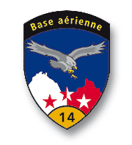**EMBA**

École des Métiers du Valais & Base Aérienne de Sion

**École Professionnelle Technique et des Métiers**

**Base Aérienne de Sion**

|  |  |  |
| --- | --- | --- |
| **Team** | **Coach** |  |
| **Electronic** |  |  |
| Borgeat Rémy – Gaëtan Fumeaux – Favre Lenny | Duay Daniel – Gaspoz Frédéric |  |
| **Mechanical** |  |
|  |  |
| Crettenand John –Mathieu Voeffray | Vouillamoz Christophe – Quinodoz André |  |
| **IDB** |  |  |
| Rodriguez Fabien |  |  |

**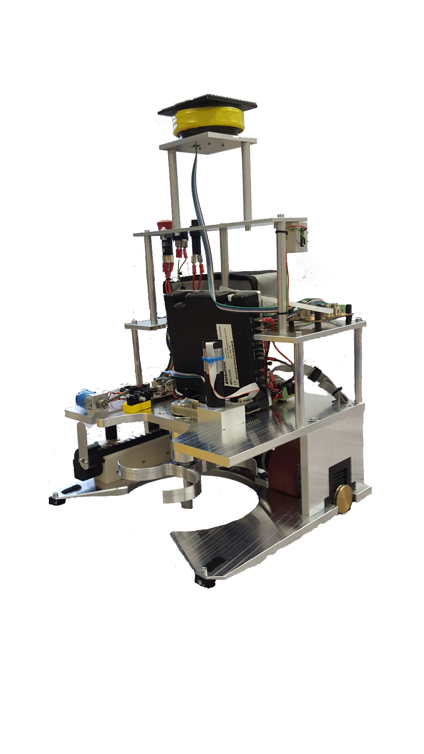**

|  |  |  |  |
| --- | --- | --- | --- |
| **Big Robot**  Mast and bracket  *IR Beacon* | |  |  |
|  |  |  |  |
|  |  |  |  |
|  | http://lesobservateurs.ch/wp-content/uploads/2015/02/drapeau-suisse-d%C3%A9chir%C3%A9.jpg  Launcher  *On its way to Mars* |  |  |
|  |  |  |
|  |  |  |  |
|  |  |  |  |
|  |  |  |  |

Drive system

*On a line*

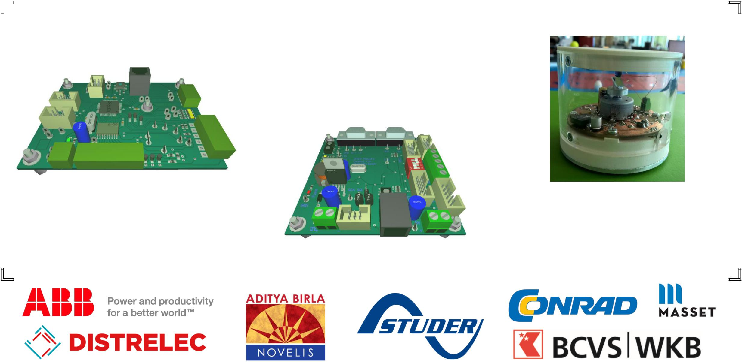

|  |  |  |  |  |
| --- | --- | --- | --- | --- |
|  |  |  |  |  |
|  |  |  | Drive system  *On a line with measuring wheels* |  |
|  | Gun cylinder  *Pick up modules* | |  |  |
|  |  |  |
|  |  |  |  |
|  |  |  |  |
|  |  |  |  |
|  |  |  |  |  |
|  |  |  | **CarteDriverGeneral electronic** |  |
|  | CartePrinc |  |  |
|  |  |  |  |
|  |  |  | **Movement card**  *uC*  *dsPIC33EP256MU806*  Manages the movements and positioning. |  |
|  |  |  |  |  |
|  |  |  |  |  |
|  |  |  |  |  |



**Principal card**

*uC dsPIC30F6014A*

Manages time, strategy, and the robots

appendices.

**dr_fritz_faulhaber_gmbh

**Small Robot**

Launcher

*On its way to Mars*

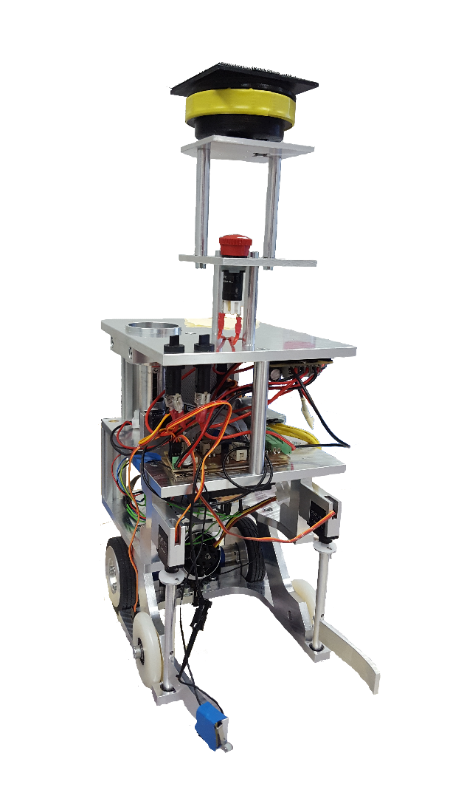

Mast and bracket

*IR Beacon*

Clamps

*To harvest titanium*

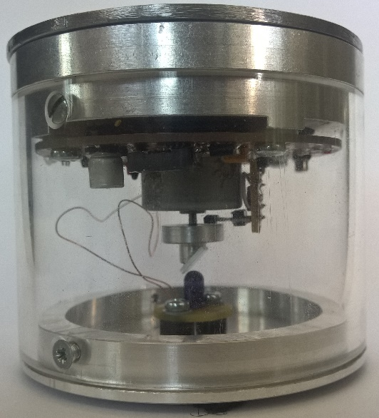

**IR Beacon**

Put on the opponent, it emits infrared with variable power all around itself.